Linear-time Sorting

Radix Sort
Input array A is a list of binary numbers each with k digits.

The base case of the function is when k = 1. In which case, the array should be organised as seen below:
Base_case(A):
a = 0;
b = len(A) – 1;
Output = zeros(len(A));
for i in range(len(A)):
if A(i) == 0:
Output(a) = 0;
a += 1;
else:
Output(b) = 1;
b -= 1;
return Output

The recursive step should examine the first digit of each number in the array to split the array into a higher and a lower array, removing the first digit as it does so and calling radix_sort(higher) and radix_sort(lower).
If first digit of A(i) == 1;
x = last digits of A(i)
higher.append(x)
else:
x = last digits of A(i)
lower.append(x)

higher_sorted = radix_sort(higher)
lower_sorted = radix_sort(lower)
add 1 as a first digit to all in higher_sorted and 0 as a first digit to all in lower_sorted
return lower_sorted.append(higher_sorted)

Arrays

Complexity of ArrayInsert
The process of inserting an element into an array requires copying all of the data to the right of the inserted element in order to push them out one space. Imagine each |[num| is an occupied spot in memory and each |o| is a vacant space. ArrayInsert works as follows:
Array stored in memory (length = 5)
|1|2|3|4|5|o|o|o| etc.
Insert value x at A(2):
|1|2|3|4|5|5|o|o| etc. |1|2|3|4|4|5|o|o| |1|2|3|3|4|4|5|o|o|
Then
|1|2|x|3|4|5|o|o|
Clearly the worst case for this is when a value needs to be inserted into A(0), and the time complexity is O(n).

Writing ArrayDelete
Similarly to ArrayInsert, the worst case is when A(0) is being deleted as the algorithm copies the value of A(i+1) into A(i) before removing (A.pop_back()) the final element. This requires a copy of every single element in the array – hence O(n) time complexity.

Stacks

Enhanced Stack Class
Tests passed.

Reverse Polish Calculator
Tests passed. Remember stack.pop() only moves head pointer, it does not output the top value, this must be done in two steps.

Queues

Enhanced Queue Class
Tests passed.

Lists

Deleting Elements from a List
Tests passed.
The worst case time complexity is constant as it is simple pointer assignment that rejoins the ends of list created be removing an element.

Binary Trees

Enhanced BinaryTree Class
Test passed.

Minimum and Maximum Element in a Binary Search Tree
Test passed. (If value > node value, go right, else go left).

Traversing the Nodes of a BST by Non-Decreasing Value
Start at the left-most branch to get the lowest value. Then head to its parent node and to its right child and repeat. The algorithmic thought process is go left at all times until you reach the end of a branch or are about to retread ground you’ve been to already. If left is unavailable, visit the parent node, then the right child and continue down the left path of that right child. Repeat until entire tree traversed.

Heaps

Building a Heap
BuildHeapAlt works very similarly to PriorityEnqueue as both place the new value at the lowest point in the heap, before calling sift up to swap elements around until the heap property (of non-decreasing elements when viewed from top to bottom) is restored.
The time complexity of BuildHeap and BuildHeapAlt should be the same as they fundamentally perform the same operation in the reverse order. However, I would expect BuildHeapAlt to be faster than BuildHeap by a constant factor between one and two depending on the properties of the binary tree. This is because SIftUp (used in BuildHeapAlt) only ever compares the value of the node it is called at with its parent note, whereas SiftDown has to check both child nodes of the node at which it is called.

Building a Heap vs Sorting
Yes. The standard binary tree mapping of array A is to set A(0) to be the root node, A(1) as its left child, A(2) as its right child and so on such that A(2i+1) represents the left child of the node A(i), and A(2i+2) represents its right child.
Now imagining A(i) > A(i+1) for all i, and observing that each parent node has a lower index in A than its children, it is clear that all parent nodes must be greater in value than all children nodes and thus the heap property is present.

Updating the Priority of a Queued Element
If each node has an assigned priority, and is stored as a binary tree, then SiftUp and SiftDown can be used to correctly order these nodes to ensure the heap property holds when considering the priority number of the nodes. Note that the priority number can be its own stored value and does not have to relate directly to the value stored at the node. (e.g. storing customer information where different customers have different subscription plans. The node may contain name and email data and the priority could be decided based on the type of subscription the customer is paying for).

Hashing

Worst-case complexity for multiple chaining
Since all elements in K must hash to one of m chains, there must always exist a subset of K with more than n elements that hashes to the same chain. This is shown to be true when considering the maximum subset size of K under different arrangements.
Max|K| >= K/m and from the question we know |K| > m*n, => |K|/m > n as required.
The worst-case complexity results when all n keys occupy the same chain and the key being searched for is at the end of that chain. In this case, the time complexity is O(n).

Other Uses of Hash Functions
A sensible hash function changes if even one bit in the key is flipped. Equivalently, passing a file through the hashing function should produce a hashkey that is unique to that file. The way to achieve this is to choose a value of m which is a prime other than two.

$$h\left(k\right)=k⋅mod\left(m\right)$$
Consider a pair of keys k and k’ that differ in the i-th bit.
$$k^{'}=q^{'}⋅m+h\left(k\right)=k+2^{i}=q⋅m+h\left(k^{'}\right)+2^{i}$$
Suppose h(k) = h(k’).
$$q^{'}⋅m=q ⋅m+2^{i}$$
$$(q' - q)m = 2^i ⇒ m|2^{i}$$
But since m is a prime number not equal to 2, this is not possible and therefore h(k) is not equal to h(k’).

Division Method for Large Keys
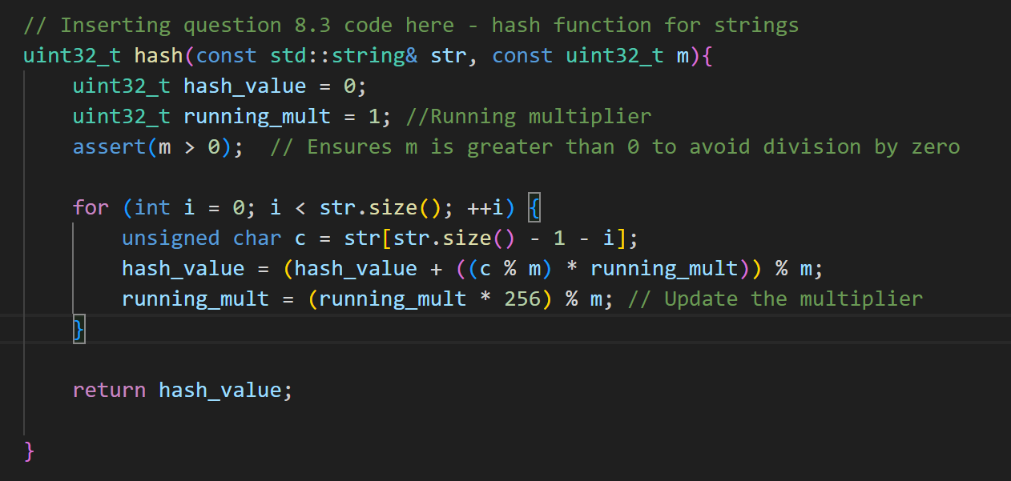

Permutation Invariance of the Division Method
256mod(255) = 1, so (256mod(255)^i = 1 for all i and thus the order of the characters does not matter because the multiple of 256 that represents position becomes a multiplication by 1.
This could be a useful property if detecting combinations were desired, but often this will be undesirable.

Graphs

Shortest Path using Adjacency List Representation
This passed the test but I had some issues trying to get the compiler to link to the correct files. I would appreciate looking at how CMake works in the tute.

Decoding Shortest Paths
Same as for 9.1

